Create presentations

Build presentations from templates
Get off to a fast start by using PowerPoint themes, that provide ready-made designs with built-in graphics, borders, fonts, and content placeholders. You can also download templates with content, such as awards and certificates.
Select a theme
Themes are ready-made presentation designs with pre-built colors, fonts, and layouts.
- Open PowerPoint. Or, if PowerPoint is already open, select File > New.
- Select one of the Themes.
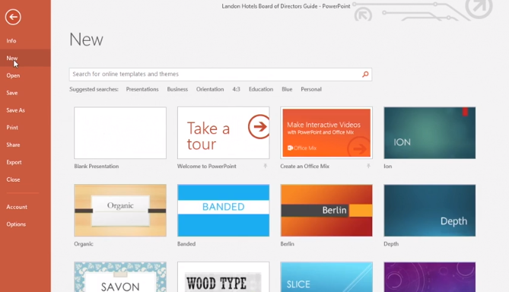
- Select a color variant.
- Browse through More images if you like.
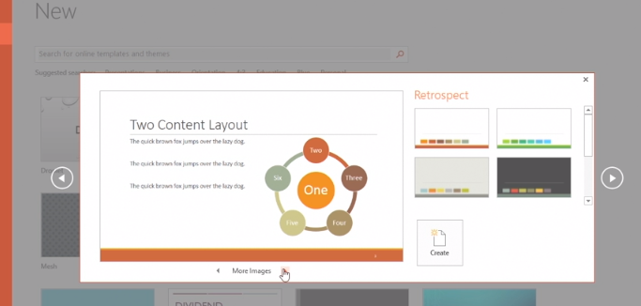
- Select Create.
- Select a placeholder to start typing.
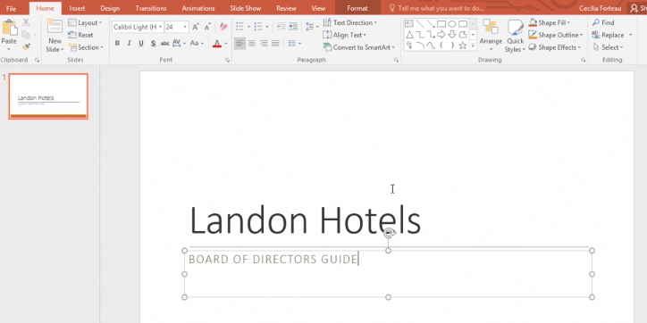
The fonts and colors depend on the theme.
- On the Home tab, select the New Slide drop-down to view other layouts in this theme.
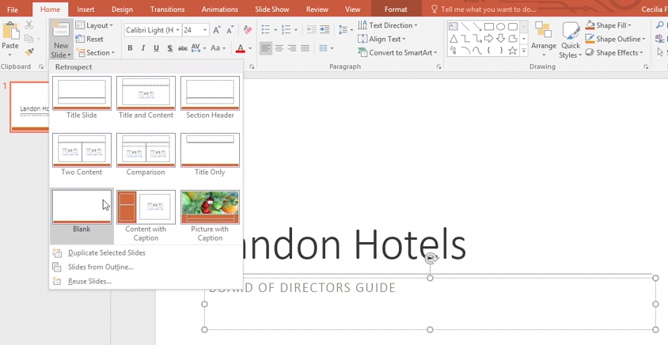
Select a Template
A template gives you a slide that's pre-made with a design theme and content built right in.
- Open PowerPoint. Or, if PowerPoint is already open, select File > New.
- Select Search for online templates and themes and type in a keyword, and select the magnifying glass.
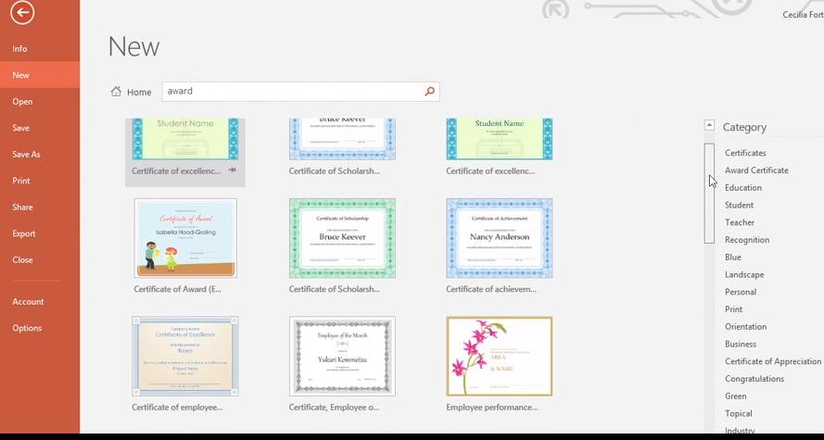
Tip: You can also select one of the Suggested searches just below the search box.
- Select a template, and select Create.
Or, double-click the template.
- Select inside the placeholder text to add or change what you'd like.
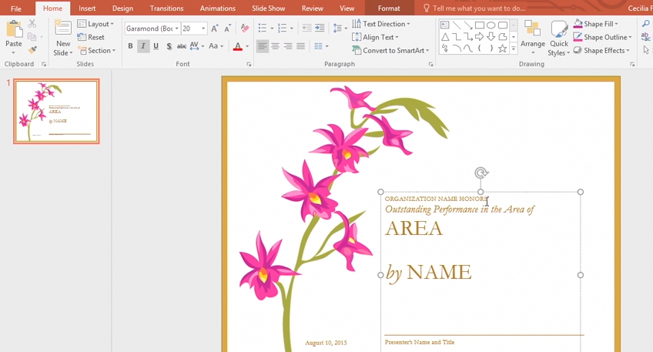
- Select File > Save As, select where you want to save it, type a name, and select Save.
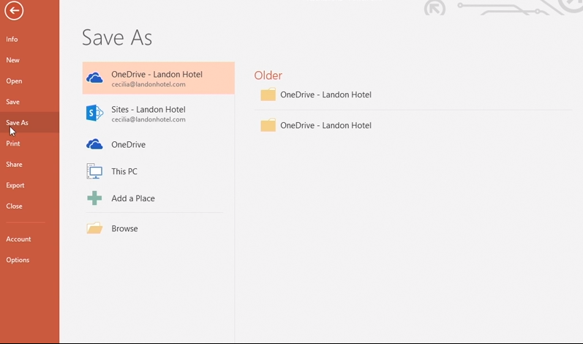
Now whenever you need it, you can open and make changes to use it again.

Create presentations from scratch
You can always do it your way when it comes to creating a presentation.
Create a blank presentation
- Open PowerPoint.
Or, if PowerPoint is already open, select File > New.
- Select Blank Presentation.
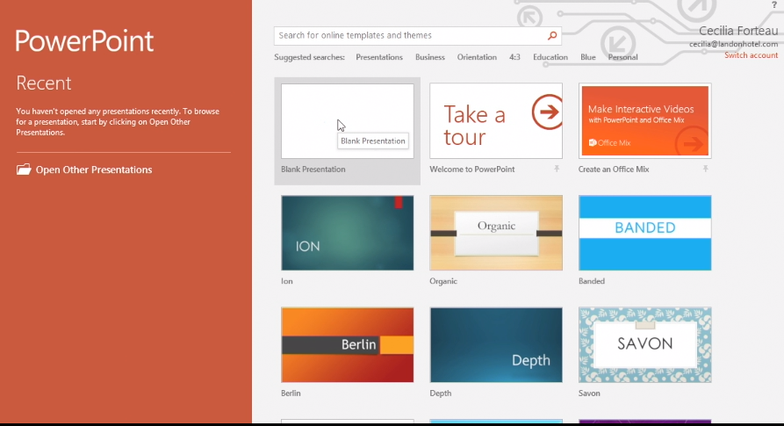
PowerPoint opens the default slide layout with placeholders.
- Click inside the placeholder to start typing content.
For example, to add a title, select Click to add a title.
As you type, PowerPoint automatically wraps the text inside the placeholder.
- Press Enter to add a new line.
If you add a new line and decide you don't want it, press Delete.
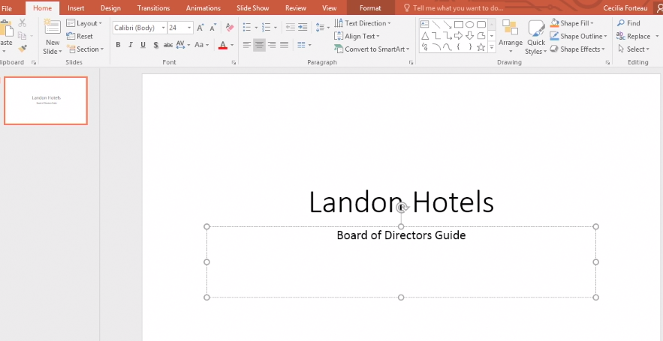
- Click outside the placeholder to see the content without the placeholder borders.
- To save your changes:
  - Select File > Save as.
  - Select a location.
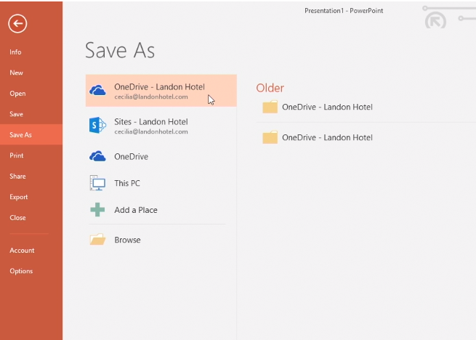
  - Type a name for your presentation.
  - Select Save.
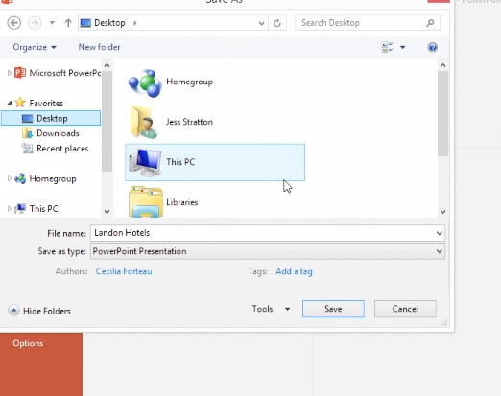
- To close your presentation, click the X in the top right corner.
- When you reopen PowerPoint, your new file is listed in the Recent list.
You can click the file to open, or select Open Other Presentations and open it from there, or Browse.
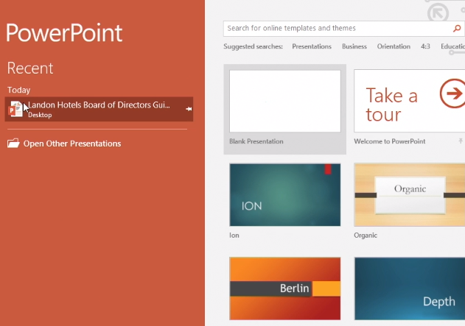

Add and delete slides
Here are the common ways to add, re-arrange, and delete slides in your presentation.
Add a new slide
- Select Home > New Slide, or select a layout from the New Slide drop-down.
- To rearrange the order of the slides, select and drag the slide thumbnail where you want it.
Tip: To select multiple slides, press Ctrl while you select each slide. Then drag them as a group to the new location.
- To add a new slide, you can also right-click a slide in the thumbnail area, and select New Slide, or press Ctrl + M.
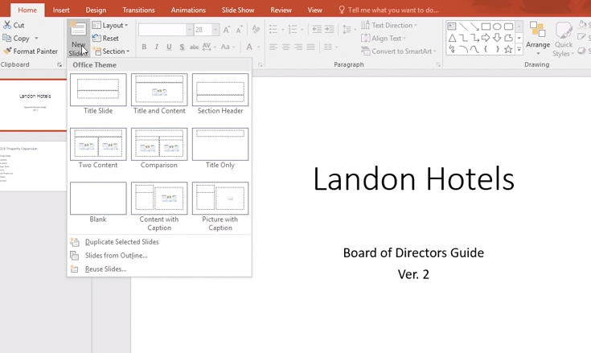
The layout of the new slide is the same layout for the previous slide.
- Select Home > Layout to select a different layout.
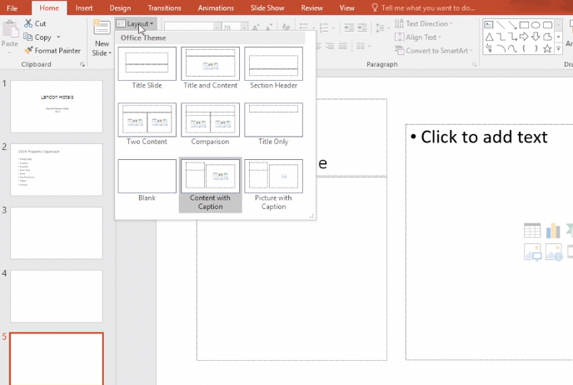
Delete a slide
- Select the slide you want to delete and press Backspace or Delete on your keyboard.
Or, right-click the slide and select Delete Slide.

Select and apply slide layouts
Arrange slide content with different slide layouts to suit your taste and preference, or to improve the clarity and readability of the content.
- In Normal view, select the slide that you want to apply a layout to.
- Select Home > Layout, and then select the layout that you want.
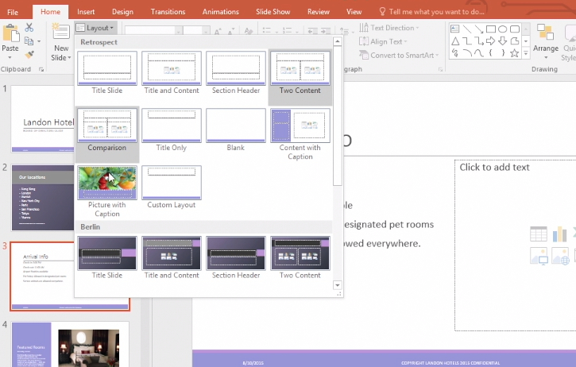
The layouts contain placeholders for text, videos, pictures, charts, shapes, clip art, a background, and more. The layouts also contain the formatting for those objects, like theme colors, fonts, and effects,
- Select Home > Reset if you made layout changes you don't like, and want to revert to the original layout.
Using Reset doesn't delete any content you've added.

